1. **Ensure you have an active slack workspace or create a new workspace:**

First go to <https://slack.com/intl/en-za/> and make sure have an active workspace:

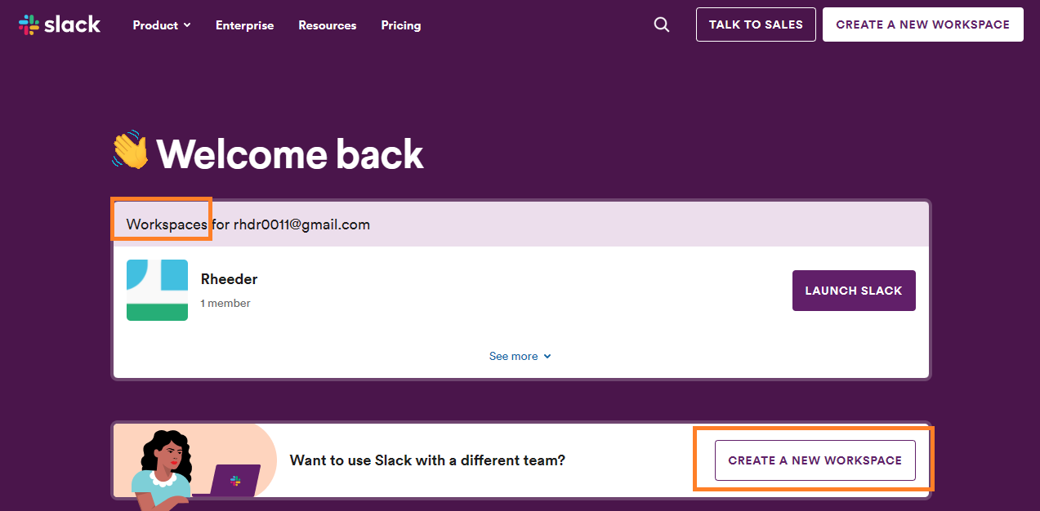

Create an account or sign in and then click ‘Create a workspace’

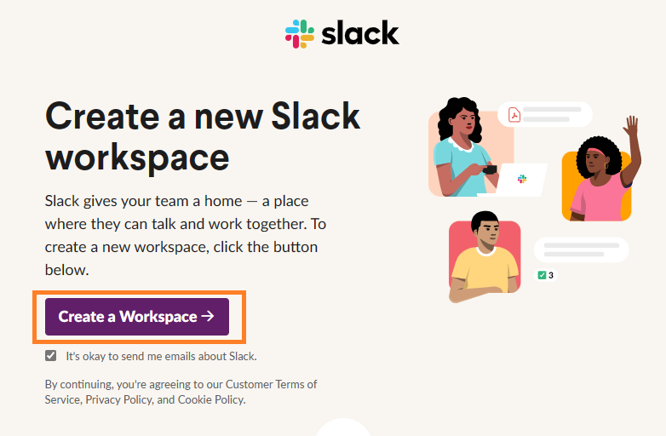

Fill out the forms then you may skip the add team mates section. You should now have a working ‘Workspace’ and a channel created

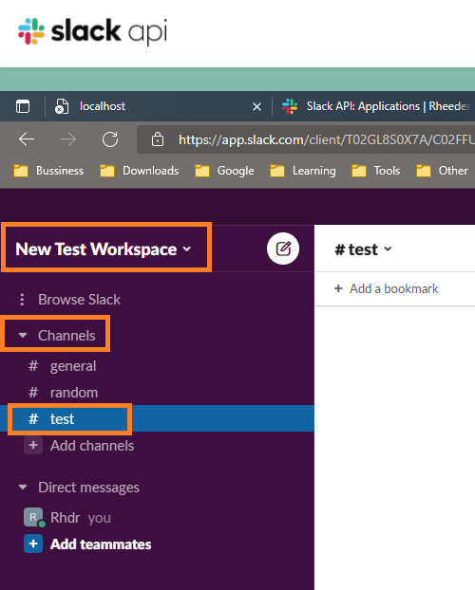

1. **How to setup your slack bot & get a Bot Authorisation token:**

Go to <https://api.slack.com/apps> and open 'Your Apps' (see the top right hand corner)

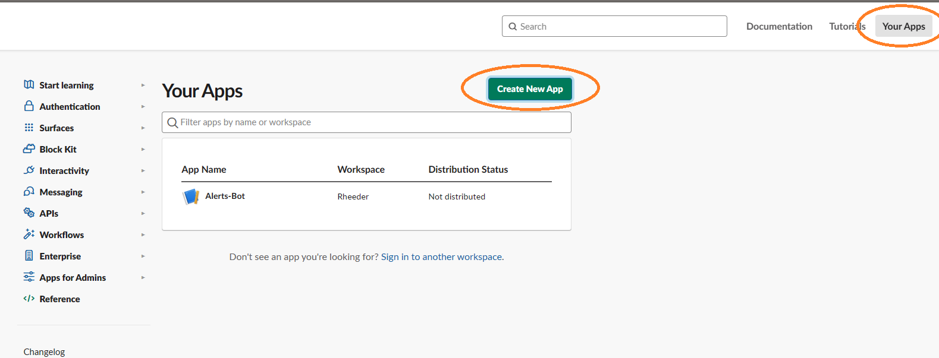

Create a new app from scratch

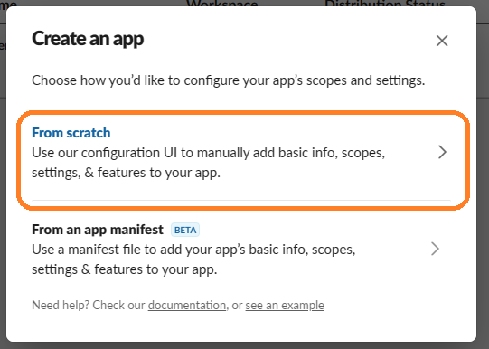

Choose a name and select your existing workspace

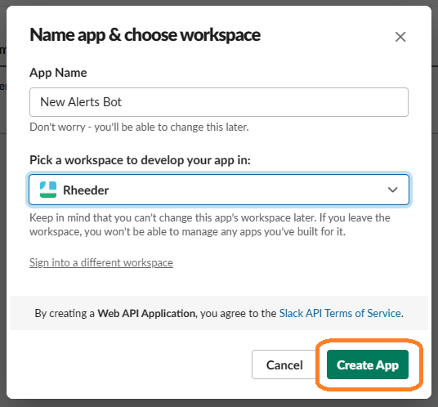

Go to OAuth & Permissions

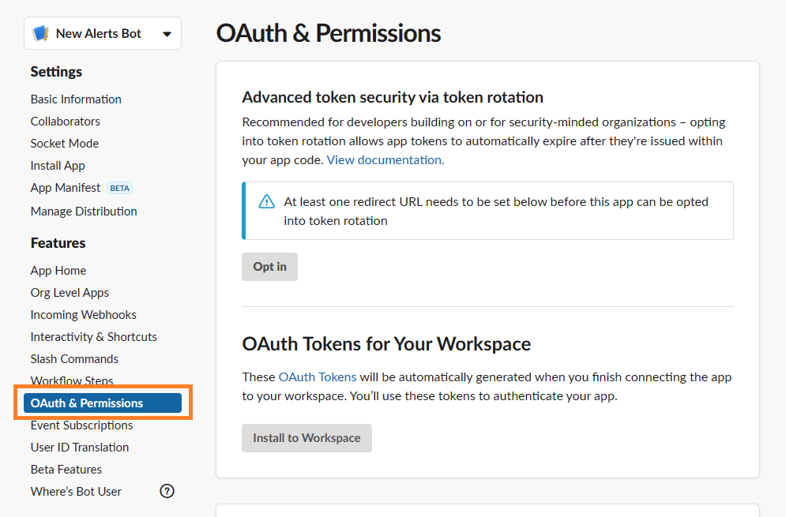

Scroll down to ‘Scopes’ & select ‘Bot Token Scopes’ & click ‘Add an OAuth Scope’

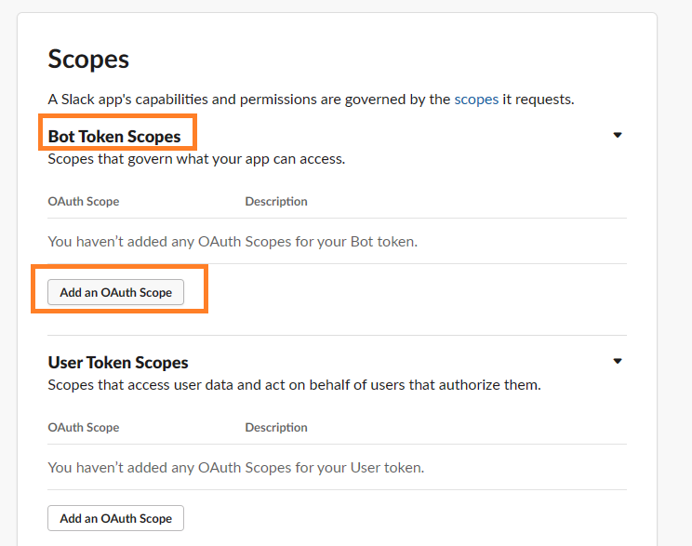

Select ‘chat:write’ permission to add the new permission to new Bot

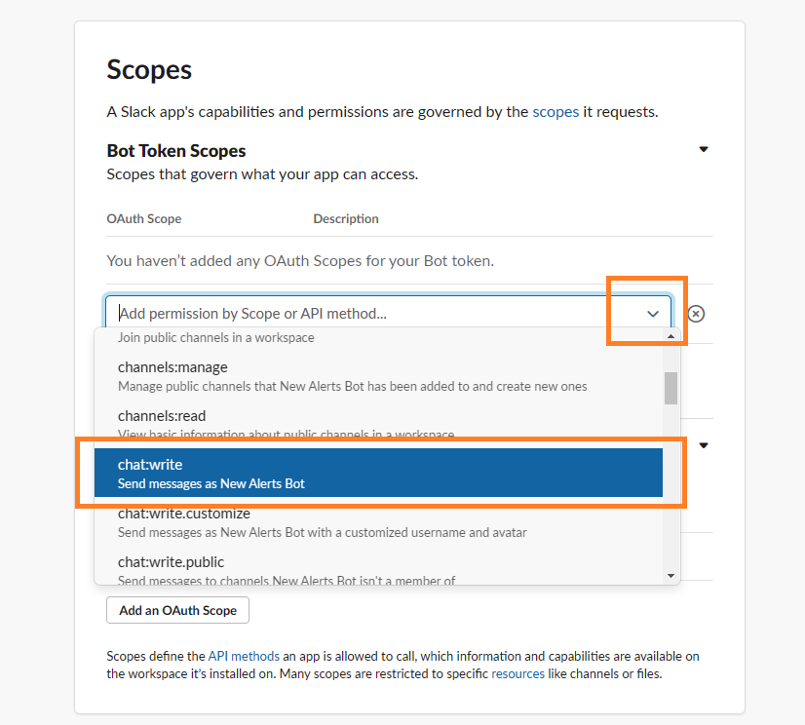

Scroll to the top and select ‘Install to Workspace’

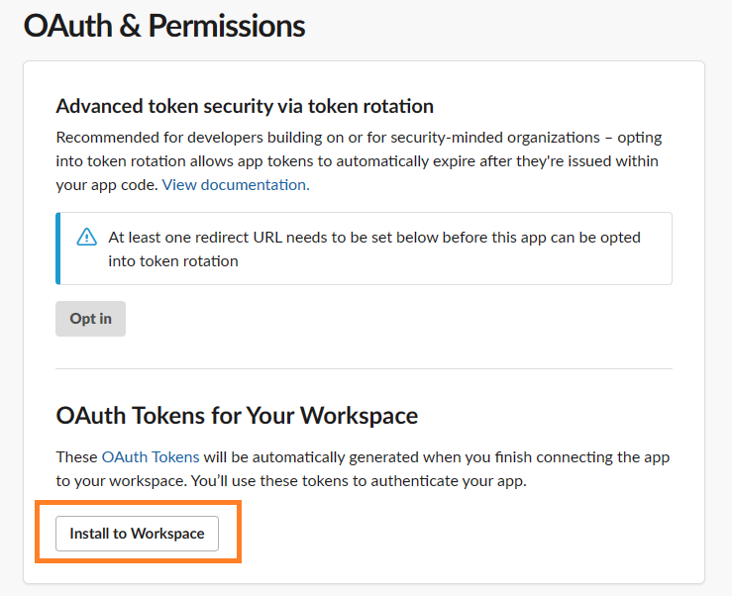

Select Allow

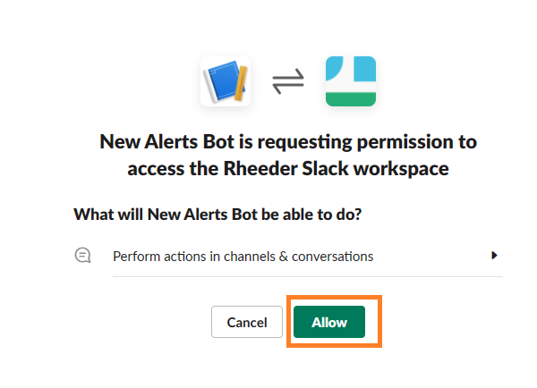

You should now have access to your ‘Bot User OAuth Token’ (Save it somewhere you’re going to use it later)

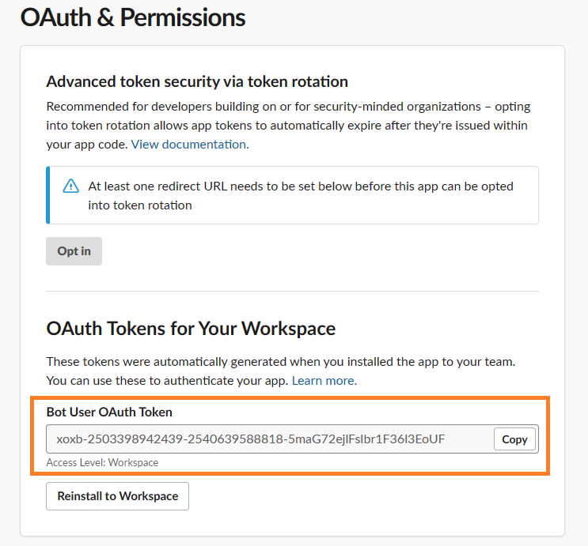

1. **Login to your existing slack workspace and add your new slack bot to one of your channels**

Login to slack and open your workspace (<https://slack.com/intl/en-za/>)  
Next navigate to your channel and click on ‘#yourchannel’ name to open up the settings for your channel (Save your channel’s name you are going to use it later – this channel’s name is = #test)

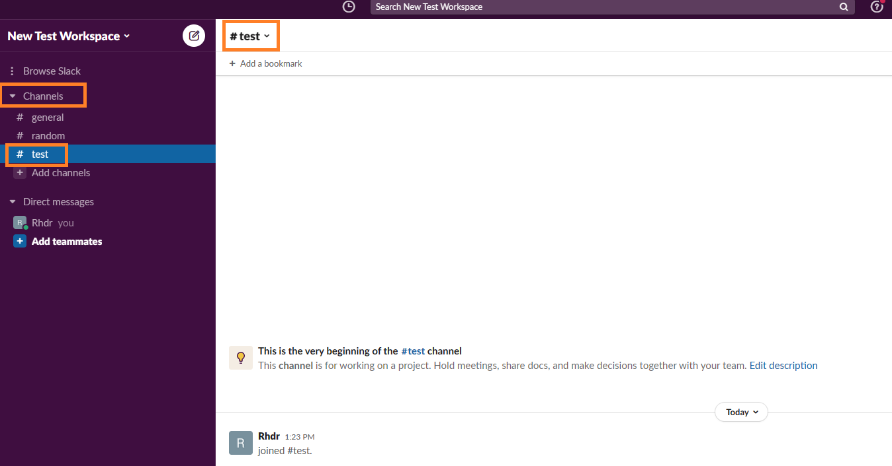

Go to integrations and click ‘Add an App’

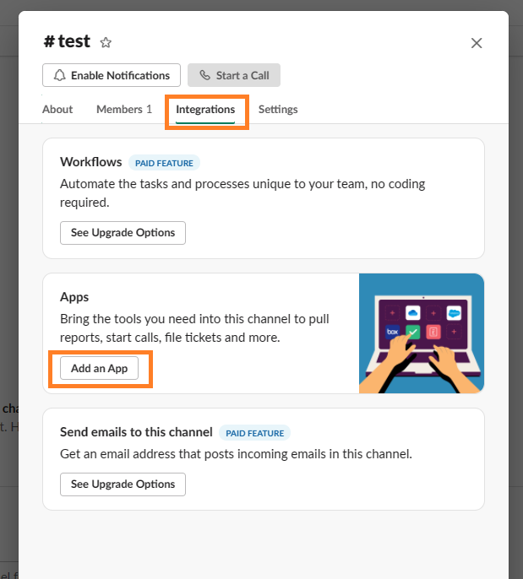

You should see your Existing Bot that you created in section 2. Click add to integrate it into your channel

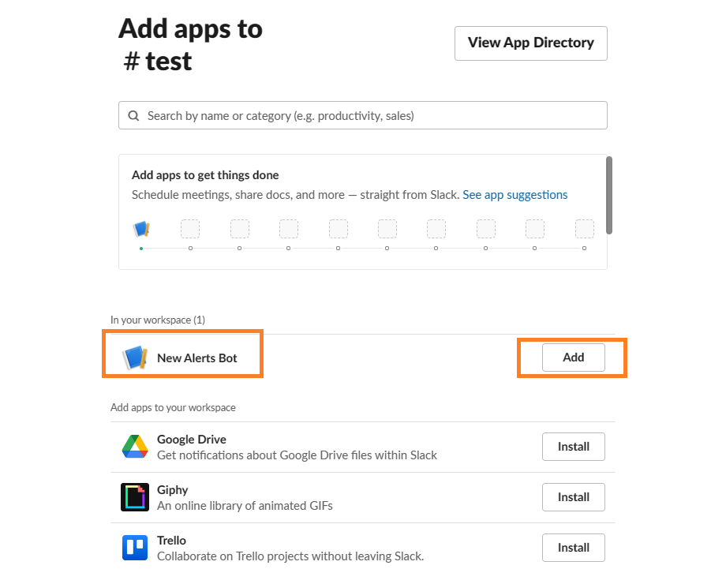

You should now see your New Bot listed on your workspace.

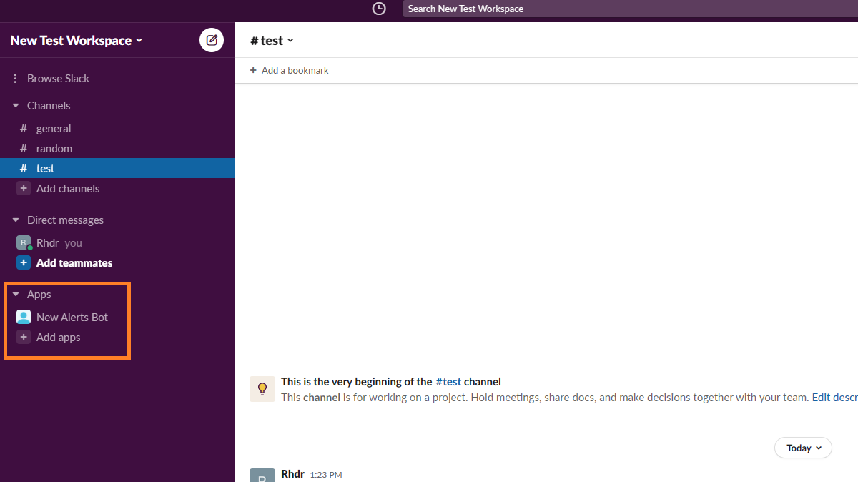

1. **Lastly connect your slack bot with the Uptime Monitor website**

Open the Uptime Monitor website and click on the ‘Add Website’ button

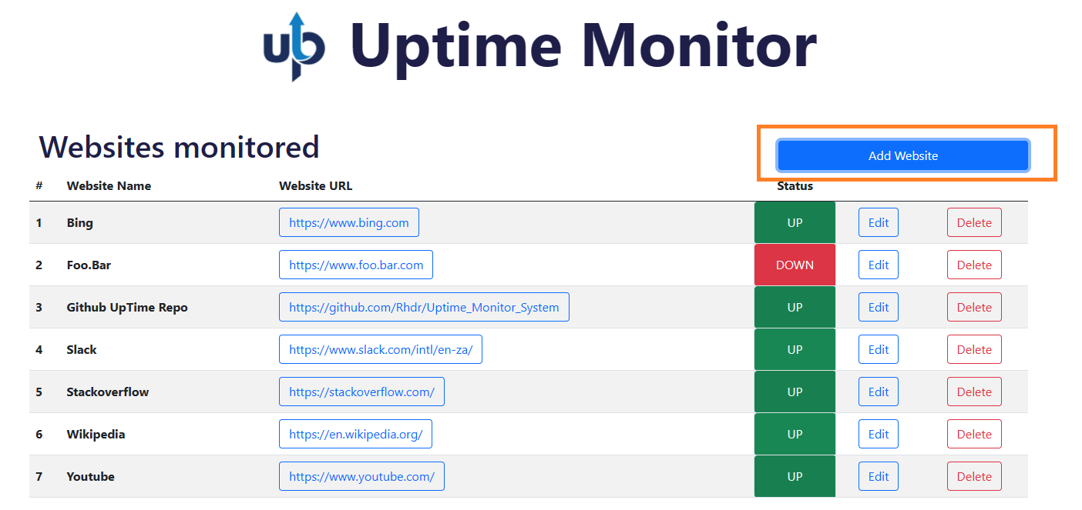

Fill in the form and paste in your ‘Slack Bot/App Authorisation Token’ & your slack channel. Click Save & Submit

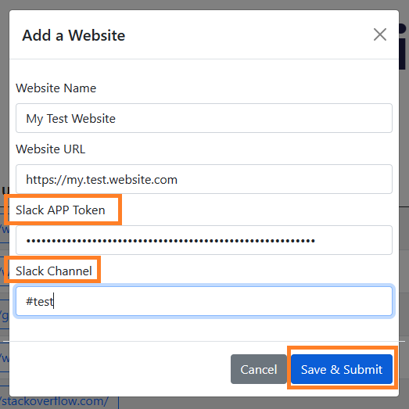

You should see your newly added website listed and your slack account should now be connected

